Part A
I
A
B
C
D
E
F
G
Objective : Name and decribe each component
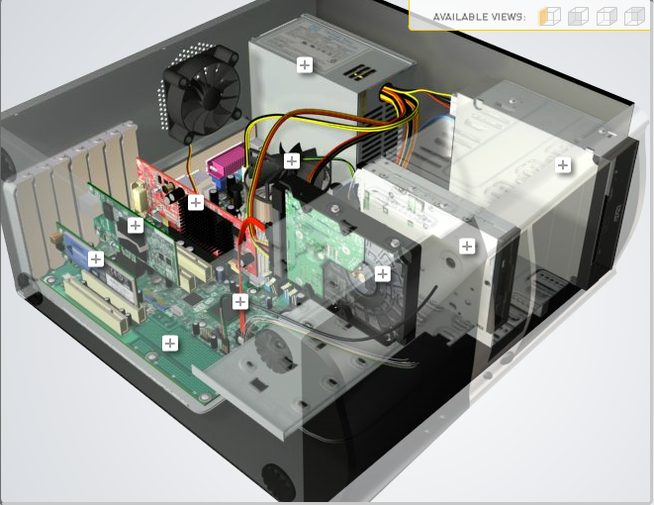
H
Download http://tinyurl.com/CW208-CAG-SIM PC Build Simulator.
Go through steps of building a PC, as you complete the simulation find and describe in detail components A to I. To run simulator first install http://www.swffileplayer.com/ and open RootMovie.swf using SWF player. Alternatively install Macromedia Flashplayer . Ideally use a simulator as listed in class.
Label | Name each component | Description
A | Expansion card | Card that can be used to provide additional functionality to the computer, such as a network card or sound card.
B | Graphics Card | Card that processes graphics and controls the output to the screen
C | CPU and CPU cooler | Central processing unit, is a processor that executes instructions in the form of a program
D | Power Supply | Provides power to the system
E | Optical Drive | Reads and writes to discs such as CD’s and DVD’s
F | Floppy Drive | A device that reads and writes to floppy disks
G | Hard Drive | Disc used for non-volatile memory that is used to read and write memory via a spinning disk that is ready by light being reflected from the disk to the disk header
H | SATA Cable | Serial Advanced Technology Attachment cable that is used for computer bus connections
I | Motherboard | Connects all the parts together and allows the components to interact with each other

Part B
Objective
Compare a pre-assembled system and the components that could be assembled to build a comparable system. After completing this practical, you should be able to:
- Identify the components of a pre-assembled system
- Locate prices for components needed to assemble a comparable system
- Compare the cost of a pre-assembled system and a self-assembled system.
If you can’t find exact match for components, find the closest possible substitute. Use the Internet and available computer-related publications as your sources for information. Examples of websites for computer parts www.komplett.ie, www.dell.ie, www.custompc.ie www.amazon.de
Prebuilt:
https://www.dell.com/en-ie/shop/gaming-and-games/alienware-aurora-ryzen-edition/spd/alienware-aurora-r10-desktop/d00awr1033?configurationid=d9294959-f177-4408-9bb6-a2ffc31387d6
MAKE SURE TO INCLUDE VALID LINKS TO WEB REFERENCES
 | Pre-Assembled Computer Package | Computer Package  Components
CPU | Ryzen 5800X | Ryzen 5800X
Storage / Memory
 |  | 16GB Crucial Ballistix 16GB (2X8) 3600MHz  Samsung 980 Pro 1TB NVME SSD
  RAM
  Hard Drive
  16GB (2X8) DDR4 3200MHz
  512GB M.2 PCIe NVMe SSD
Input/Output
 | Dell Wireless DW1810 Bluetooth 5.0  Optical Mouse MS116AW  Alienware 25 Gaming Monitor | AW2521HFA 25”  None  E2600 Gigabit Ethernet | Razer Ornata Chroma  Razer Viper Mini  Asus VG248QE 24” HD 144hz  Razer Kraken  TP-Link TL-WN881ND Wi-Fi Adaptor
  Keyboard
  Pointing Device
  Monitor
  Speakers
  Network Adapter
Bundled Software  (Including Operating System) | Windows 10 | Windows 10
Total Cost | €2310.97 | €2000

Part C
Objective
You have been asked by a family friend to assist them with a computer purchase. They’re unfamiliar with technology and the terms used and have presented you with two alternatives machine choices. They would like to be able to write word documents, surf internet and play Minecraft © Mojang and Half-Life © Valve Software. They are considering playing Fortnight but are not sure yet, as it depends on machine cost and if they can extract some money from their Bitcoin wallet.
Compare Personal Computer Option A and B in relation to each of the side headings and recommend a system and any alterations.

 | Personal Computer  Option A | Personal Computer  Option B
CPU | 2.2 GHz Intel Celeron 450 | 3.2 GHz Intel Core i5
Memory
  Cache
  RAM
  Hard Drive
  CD-ROM/DVD
  512 KB Cache
  4 GB RAM
  320 GB Hard Drive
  DVD+/-RW drive
  4 MB Cache
  8 GB RAM
  1 TB Hard Drive
  DVD+/-RW drive
Input/Output
  Keyboard
  Pointing Device
  Screen
  Speakers
  Network Adapter
  USB multifunction keyboard
  USB optical mouse
  20’’ HD flatscreen monitor
  Multimedia Speaker System
  Integrated 10/100/1000 Ethernet
  wireless multifunction keyboard
  wireless optical mouse
  25’’ HD flatscreen monitor
  Dolby Surround Sound Speakers
  Integrated 10/100/1000 Ethernet

Recommendations
I would recommend Option B as the CPU is a new processor and has a higher clock speed which means it can process more information faster. The higher cache allows the PC to spend less time accessing memory meaning it will be faster. The higher RAM allows more processes (such as programs and other tasks) to be open at the one time without hindering performance. The 1TB hard drive will allow you to store over 3x the amount of data which means you can install more games and have more data without needing to upgrade. Both PC’s have an optical drive which allow you to use disks with your computer. Option B has a wireless mouse and keyboard which allow you to use the devices without being hindered by cables but they either will have to be charged or take batteries. Option B has a larger screen which provides a better viewing experience. The surround sound speakers provide a better audio experience as this means the sound will come from directions which will provide a more realistic experience as sound will only come from the direction it actually came from. Both PC’s use ethernet which means they require an ethernet cable to have access to the internet.

For general productivity such as writing word documents and surfing the internet, Option B is better as it will complete tasks faster and will allow you to have more tabs in your browser open at the one time. It also will provide a better and smoother experience with gaming and will allow you to install more games onto your PC without having to upgrade.

I would recommend also purchasing a graphics card to be able to do crypto mining/send bitcoin and to be able to play more modern games with more intense graphics requirements.

Your Recommend System
Personal Computer
Recommendation
CPU | AMD Ryzen 5 2600X
Memory

  RAM
  Hard Drive
  SSD Drive
  Corsair Vengence 16GB (2x8) 3200Mhz
  Western Digital 1TB blue
  Crucial 525GB SSD
Input/Output

  Keyboard
  Pointing Device
  Screen
  Speakers
  Network Adapter
  GPU
  Razer huntsman mechanical keyboard
  Razer Viper ultimate
  Asus VG248QE
  Razer Kraken Pro
  TP-Link TL-WN881ND Wi-Fi adaptor
  Asus ROG Gaming GTX 1070

Hand up this practical report at the end of session and ensure it has been checked
Student Name | Denis Perepelyuk | Student Number | C00259076
Date | 27/10/2021 | Checked
Group | A

